Thomas Holland
in the Realm of the Ogres

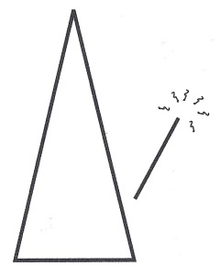

by
K. M. Doherty

Text Copyright © 2016 by K. M. Doherty
All rights reserved. No part of this publication may be reproduced, distributed, or transmitted in any form or by any means, or stored in a database or retrieval system, without the prior written permission of the author.

Thomas Holland and all related characters and elements are TM of and © of
K. M. Doherty

Wizard’s Mark Press

ISBN-13 978-0-9915720-5-2

LCCN: 2016942435

The Thomas Holland Series
Book 2

Visit the website: www.ThomasHollandBooks.com
Visit us on Facebook: www.Facebook.com/KMDoherty.author
Tweet with the author on Twitter: @authorKMDoherty

Printed in the USA

Cover art by: Daniel Johnson of Squared Motion
www.squaredmotion.com

Map Graphic, Layout & Cover Design by: K. M. Doherty
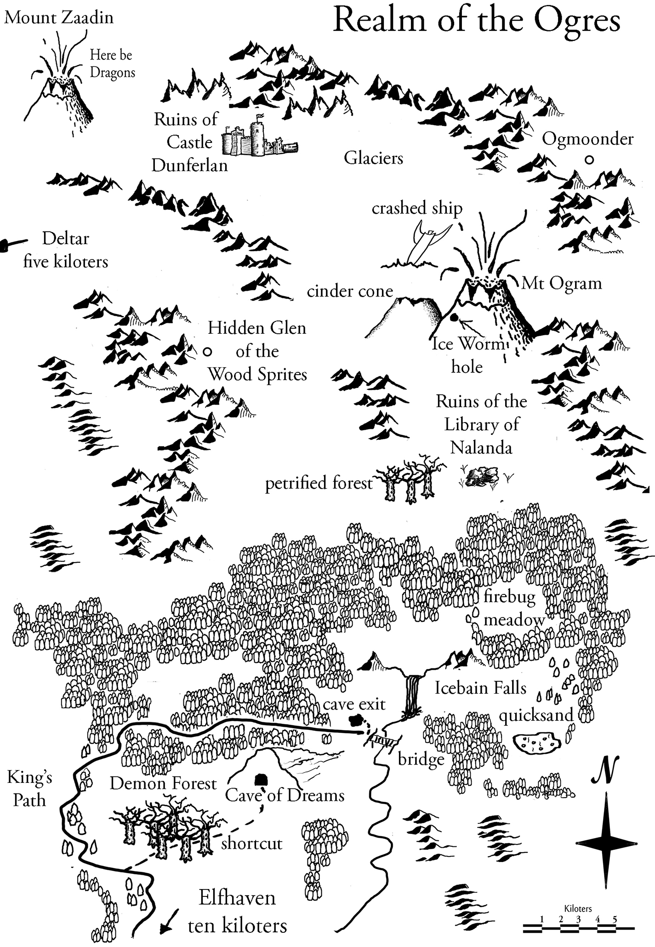

Chapter 1: Treachery, so it begins…
Tom ducked as a book magically floated by, narrowly missing his head. “Anything you wanna look for while we’re in the library?” he asked Avani.
The Elfhaven library had the usual dry musty smell of old parchment and leather, but an unusual chill surrounded them.
Tom rubbed his hands together vigorously, then placed them into the pocket of his Chicago Cubs hoodie. He gazed at the ceiling high above them. For the hundredth time he stared in awe at the massive crisscross wooden beams that capped the warehouse sized room. The dark ceiling stood in stark contrast to the gigantic windows whose light cast eerie shadows everywhere.
Statues of monsters and strange beasts adorned alcoves along the walls, each looking poised to leap from their pedestals.
“Shush,” whispered Avani, brushing a lock of her long golden hair from her face, exposing a tall pointed elven ear. “I want to find a book of maps so we can trace the route the king’s expedition is taking.”
“The Guardian of the Citadel could show us a 3-D holographic map,” suggested Tom.
“I want a book of real maps. One you can touch, feel the roughness of the parchment, hear the crackle as you turn the pages.”
Tom shrugged.
A few people sat quietly here and there, though it was late and the library was mostly deserted. Rows of bookshelves towered high above them, but posed no problem for library patrons. All they had to do was ask the librarian for a book and it magically floated to their desk, opened to wherever they’d left off, and even turned the pages for them.
Avani carefully scanned the elvish runes at the head of each aisle. “Where’s Goban?”
“He went to the castle to talk to Prince Devraj.” Tom still marveled at the fact that just two weeks ago, he’d been in his room in the suburbs of Chicago, putting the final touches on his robot Chloe. He’d always been a nerd and he definitely didn’t believe in magic. Well, at least until he went through the portal at Mom’s lab and ended up in Elfhaven. Now, only two weeks later, his best friends were Goban, the bright twelve year old son of King Abban, the leader of the dwarf nation, and Avani, an equally bright, magically gifted thirteen-year-old elven girl. Avani was not only the last Keeper of the Light, but also The Chosen One by the Magic Crystals. This would have been totally unbelievable two weeks ago. Now it seemed normal. “Amazing!” he said out loud.
“What?” asked Avani.
“Oh, nothing. Just thinking.”
As they turned down a narrow aisle between two tall rows of shelves, a book floated off the stack right in front of Tom. Stopping abruptly, he leaned back doing his best to avoid getting hit. Still, as it passed by the book brushed his nose then pivoted sideways in mid-air and smacked his ear. It was headed in the direction of the librarian’s desk. Tom spun around and glared at the ghost who called himself “The Librarian.” The spirit’s gaze immediately dropped to his desk, busying himself with his work. Did the apparition just smirk? Tom’s frown deepened.
“Come on,” said Avani. “What are you waiting for?”
Tom watched the ghost suspiciously for a moment longer, then followed her. “We should’ve waited for your little brother. He likes the library.”
“Kiran isn’t interested in maps. He’d much rather be with the adults, searching for the lost magical artifact,” she replied.
“So would I,” muttered Tom. He paused, then added, “Technically it’s not lost. And it’s not magic, for that matter. We know where the power source is.”
“Yeah, deep in the Realm of the Ogres.”
“Hmmm. So where’s Kiran, anyway?” asked Tom.
“At home, playing with your pet.”
“Kiran and Max sure have taken a liking to each other.”
As they strode down the dark aisle, the bookshelves towering above them, Tom reached out and let his fingers flap across the spines of several ancient leather-bound books embossed with ornate gold lettering. The leather felt dry and gave off a faint musty smell.
“I can’t read these titles,” said Tom. “Isn’t the magic supposed to translate the words?”
“Just spoken languages. Many old elvish scripts and runes exist, plus all the dwarvish dialects. I can read five or six. Grandfather claims he can read twelve, but I think he’s lying.”
“Nadda, lie?” said Tom. “No way.”
Avani shrugged.
Tom paused. “So where is this book of maps? I thought you said you could read these signs.”
“I can,” she said, craning her neck to see down the aisle.
“Why don’t you just ask The Librarian?”
“I can find it myself,” she said sharply. “Besides, you know how tiresome that ghost can be. Oh, there it is.” Avani headed briskly down the row. Tom watched her go.
Two more books flew off the shelves in rapid fire, one on each side of Tom. This time he managed to miss getting slapped in the face by both of them. Tom glanced over his shoulder at The Librarian, but he was talking with someone, looking the other way.
As Tom turned to follow Avani he heard voices in the next aisle. Normally, he would have ignored them, but he thought he heard one of the voices whisper ‘the artifact.’ Tom stopped and looked around. No one was watching, so he slid a book off the shelf, leaned casually against the bookcase and pretended to read.
“Did they leave?” said a sinister voice.
“Yes.”
“When?”
“This afternoon.”
Two voices were speaking, but Tom could barely hear them. A small gap between two large books stood off to his left. Tom scooted over.
“Has He been notified?”
“Yes.”
“Then the trap is set.”
By now Avani was down at the far end of the aisle holding a book and gazing at it intently. Tom tried to catch her attention. “Pssst,” he said, waving his own book frantically. She didn’t respond. Tom frowned, then leaned against the bookshelf and pretended to read once more.
“We’re to meet Him tonight,” the sinister voice continued.
“Where?”
“The old granary.”
“When?”
“Half past midnight.”
Tom waved both hands at Avani. “Pssst,” he said, a little louder this time. She still didn’t notice.
“Did you hear something?” the voice hissed.
“No.”
Someone moved in the other aisle. Books were thrown. Suddenly a huge eye peeked through the bookshelf. Tom whipped around, his back to the bookcase. A giant hand thrust through the shelf right beside Tom’s head. A ring in the shape of a skull adorned one of the fingers. The skull’s eyes began to glow a deep blood red. Books crashed to the floor as the hand thrashed around beside him. Another hand burst through the bookshelf on Tom’s other side, scattering still more books. Grabbing Tom’s hood in its fist the hand jerked back, slamming Tom hard against the cabinet.
“I’ve got him!” cried the voice.
“Avani,” hissed Tom, his hoodie now tight about his throat. He couldn’t breathe. Tom got a glimpse of her but she was still intently studying her book.
The sound of fabric tearing filled his ears. Glancing up in horror, Tom’s hoodie tore as the out-thrust fist pulled harder…

