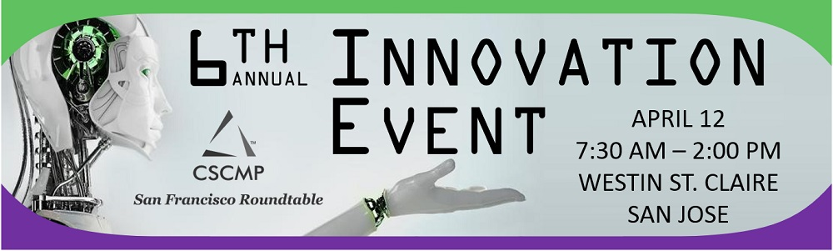

Robotics, Artificial Intelligence, Women in Logistics Key Features at 6th Annual Innovation Event April 12, 2018
​​The Council of Supply Chain Management Professional's (CSCMP) dynamic San Francisco Roundtable has announced the lineup for its 6th Annual Innovation Event April 12, 2018 in San Jose - a veritable 'Who's Who' in Robotics and machine learning and global supply chain management.
Roundtable President Michele Carroll will frame the event with a breakfast keynote, “Global SCM in an Interconnected World – Roles for Robots, AI and HUMANS!” Bob Bowman, managing editor of Supply Chain Brain, the premier website and magazine covering global supply chains, will moderate two panels – comprised of senior executives from Robotics and Artificial Intelligence: Kindred AI, HDS Global, Savioke, Fetch Robotics and Kinema Systems.

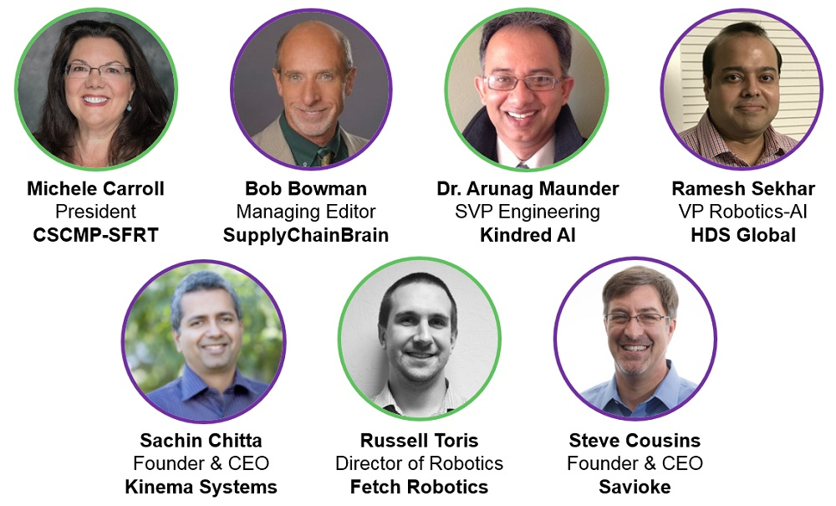

And finally, the luncheon will feature discussion of Carrollco Marketing’s ‘#MeToo: Women in Logistics Edition’ survey findings with ALOM CEO Hannah Kain and President and Founder of Resilinc, Bindiya Vakil.
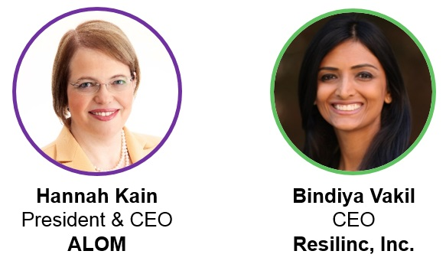
"CSCMP San Francisco has outdone itself with this leading-edge array of C-level executives in robotics, artificial intelligence and supply chain innovation - creating a forum for powerful learning and connection," said Ms. Carroll.


For more information and to register, please go to www.cscmpsfrt.org. Want to Attend But Out of Town? Event Presence is providing up to three virtual attendee robotic devices to help you participate!

