Cedar Breaks © Band Releases New Award Winning Song
PRESS RELEASE February 28th 2018
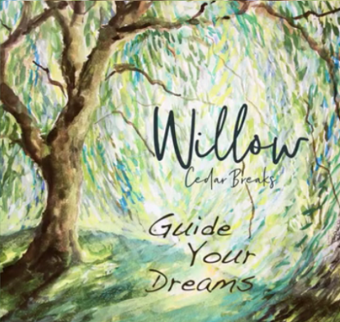
https://youtu.be/GtUIuuyXhM8
Salt Lake City, Utah, February 28th (Newswire.com) - Cedar Breaks © Band recently released, “Willow”, a new song and Music Video that has won over a dozen awards in Film and Music Festivals across the country. “Willow” was written by band member Rebecca Croft, who got her inspiration with the metaphor of the magnificent scenery of the endless mountains of Northern Utah and pondering how she could share those memories in the loneliness that is present when a loved one is away.
“Willow” speaks of how love transcends distance and time……The surprise ending was a last-minute adaptation realizing the great sacrifices that are made every day by our courageous men and women in uniform, and that we sometimes forget that the sacrifice is two sided. Asked to describe the song for someone that has not heard it, one band member replied, “It’s a simple lullaby about true love and longing for someone that is away. We also wanted to find that place between sleep and awake that is very special and to give our listeners something to dream by.”

Prior to “Willow” the Band recently crossed their genre line with the song “Ayre” and won a number of awards including “Best Rock Song, “Best American Song” and “Best Pop Music Video”. Though the basic trend of Cedar Break’s © music is labeled “New Age Folk,” the band is very diverse and loose with that designation, presenting songs with rock, blues, bluegrass, and even gospel leanings. They combine strong and interesting harmonies with diverse settings of instrumentation including Classical guitar, rock guitar, violin, piano, banjo, and drums.

In the past few years, Cedar Breaks ® Bands’ media has been featured in music and film festivals across the country, receiving awards winning for best country song, best music video, best short video, best rock, best musical documentary, best historical documentary, and best of 2016.
Their music has also been featured in the historical novel “Upon Destiny’s Song,” the historical documentaries “Walking in Obedience, the Ole Madsen Story,” “Sweetwater Rescue,” and the children’s book “My Dog.” Another children’s book featuring their music is due out in 2018, published by Guardian Angel Publishing and called “Re-Run.”
The Band believes that the message of their songs and media, which includes music, films, music videos and books has the power to help ask the right questions and that answers can come to those that will take the time to listen.
The interesting combinations of style, age, and different musical backgrounds of the band members has produced a sound that has been noted as being “fresh, distinctively different and timeless.”
The members of the band include; classical guitarist Mike Ericksen, guitarist and pop singer Michael Gibbons, classical singer Rebecca Croft, pop singer Diana Rogers Glissmeyer, and banjo player Keith Behunin.
They also have a talented naturalist photographer that they work with, Norm Bosworth from BCI video; and they have a dancer, BYU student Chanel Kostich.
Cedar Breaks ® Band love making films that highlights the beauty of our state (Utah) and our diverse culture.
There is also an interesting inter-faith part of their story. The Band’s music and videos have also been played at many Christian music and film festivals across the country and even winning some. One band members pointed out, “We have so much is common and societal goals with other faiths, so we want to find ways to celebrate these and to work together. Though the band presents its media as non-denominational, they bring the spirit of who they are to the world. Cedar Breaks © believes that their message can transcend the different faith traditions.”
Cedar Breaks © Band is part of Empath Media LLC
Contacts:
Mike Ericksen
Empath Media LLC
ericksen.empath@gmail.com
www.cedarbreaksband.com
Some of the band's most popular songs and music videos that apply to Utah include:
Eutaw (filmed throughout Utah)
Prayer (filmed on the shores of the Great Salt Lake Award Winner)
Light (used at the 2002 Winter Games; filmed in the Wasatch Mountains)
Always Mine (filmed at the Salt Flats)
