ENVIRO TECH CHEMICAL SERVICES, INC.

Mailing Address: Media Contact:
500 Winmoore Way Brent Bankosky, Chief Operating Officer
Modesto, CA 95358 Ph: (209) 232-2225
(209) 581-9576 e-mail: bbankosky@envirotech.com
FOR IMMEDIATE RELEASE

PRESS RELEASE

Enviro Tech Chemical Services, Inc. Completes Installation of Largest Peracetic Acid Delivery and Dosing System in US

Modesto, CA – January 17, 2018 - Enviro Tech Chemical Services, Inc. today announced that the Metro Wastewater Reclamation District in Denver, CO has begun disinfecting their wastewater effluent with Enviro Tech’s peracetic acid (PAA) product called Peragreen® WW (15% PAA) as a full-scale demonstration. This new bulk delivery and dosing system at the North and South Plant with a capacity of > 30,000 gallons of bulk PAA storage capacity is the largest operational system for wastewater treatment in the US.

The Metro Wastewater Reclamation District is the wastewater treatment authority for most of metropolitan Denver. They are a large, stand-alone special district formed by the Colorado legislature as the Metropolitan Denver Sewage Disposal District No. 1 in 1961 to provide wastewater transmission and treatment services to member municipalities and special connectors in compliance with federal, state and local laws. The design capacity of the wastewater treatment system is 220 million gallons per day (MGD) with a daily average flow of 146 MGD.

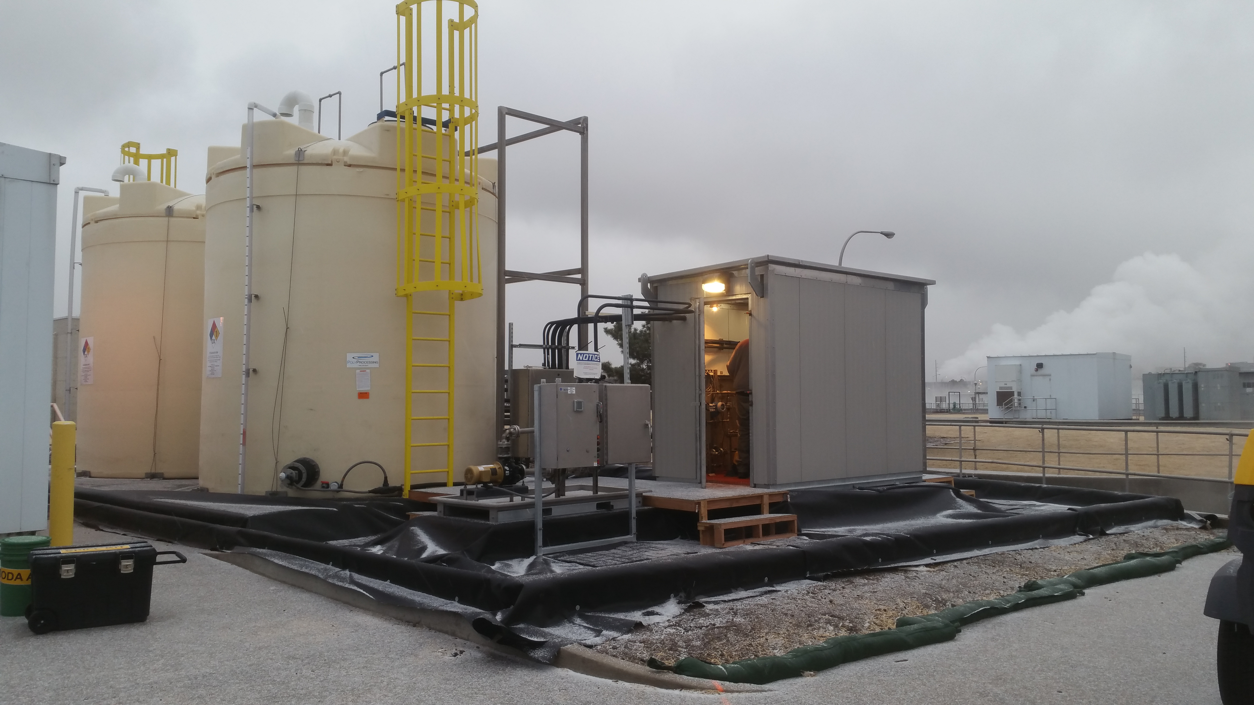
Metro Wastewater Reclamation District: North Plant PAA Storage & Delivery System

From Mike Harvey, Enviro Tech’s President & CEO, “Enviro Tech has the technical and engineering expertise as well as the PAA production and logistics capacity to install and service large-scale secondary effluent treatment systems throughout the US. Metro Wastewater Reclamation District required Enviro Tech to complete the installation of the peracetic acid delivery and dosing system in less than 6 months and we delivered on-budget.”

Enviro Tech is unique with dual peracetic acid manufacturing facilities on the West Coast and South East of the US which lowers delivery costs and guarantees reliability. Enviro Tech’s peracetic acid formulations were developed over the past 15 years and are exceptionally effective at disinfecting municipal wastewater without the potential for the formation of toxic halogenated disinfection by-products.

About Enviro Tech:
Enviro Tech Chemical Services, Inc. is one of the leading manufacturers of peracetic acid and bromine based biocides in the world. Founded in 1991, Enviro Tech offers a full line of EPA and FDA approved biocide products for markets such as industrial water treatment, meat and poultry processing, agriculture, oil & gas, municipal wastewater treatment and others.

Enviro Tech currently holds 25 parent EPA registrations and 12 FDA Food Contact Notifications, as well as 12 US patents. Manufacturing operations are located in Modesto, CA and Helena, AR with a combined 270,000 sq. ft. of manufacturing space. Enviro Tech also has expanded internationally with operations in Japan, Mexico and Chile. For further information, please visit www.envirotech.com or contact us directly at: customerservice@envirotech.com.

