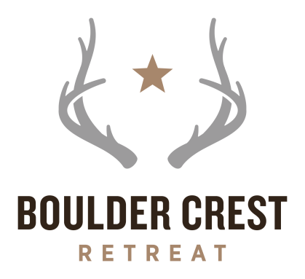

FOR IMMEDIATE RELEASE CONTACT: Ken Falke
ken@bouldercrestretreat.org
(571) 344-2341

Christopher Clements Joins the Board of Directors at
Boulder Crest Retreat for Military and Veteran Wellness

Boulder Crest Retreat for Military and Veteran Wellness is expanding to Tucson, Arizona with a new board member

BLUEMONT, Virginia – (May 15, 2017) – Boulder Crest Retreat for Military and Veteran Wellness, a free program that offers combat stress recovery programming, is expanding to Tucson, Arizona. They announce the addition of Mr. Chris Clements who joins their board of directors.

“With the acquisition of a 130-acre ranch just south of Tucson, I am excited about Chris’s addition to the board and his deep rooted ties in Arizona,” says Ken Falke, chairman and founder of Boulder Crest Retreat. “Chris will bring a new dimension to our board and is exactly what we need now that we are adding our Tucson presence to serve the southwest region with our innovative combat stress recovery programs.”

Christopher W. Clements (Chris) is the former Vice Chairman and CEO of Golden Eagle Distributors, Inc. For nearly 75 years, Golden Eagle served as a family-owned Arizona-based wholesaler for several major national brewers including: Anheuser-Busch-InBev and Sierra Nevada. In March of 2016, Golden Eagle was sold to Phoenix-based Hensley Beverage Company.

A dedicated philanthropist, in 2003, Chris established The Wings Like Eagles Foundation, a private, employee-supported foundation to provide additional financial support to a variety of charities in communities served by Golden Eagle. By the end of 2015, The Wings Like Eagles Foundation granted nearly $2 Million statewide to many worthy organizations.

Chris is a recognized leader and Legacy Member of the Arizona Chapter of the Young Presidents Organization (YPO). Chris has served in a variety of positions including: 2014-2015 Chapter Chair, 2013-2014 Education Chair and 2011-2012 Membership Chair. Chris is also active in YPO-WPO International having served as Past Chairman and Founder of the Global Diplomacy and Public Policy Network (GDPP); and, Champion of the Conservative Global Public Policy Forum. For several years, Chris has co-chaired the “YPO Inside Washington Seminar” in Washington, DC. In 2012, 2013 and 2014, Chris was honored with the YPO-WPO International’s “The Best of the Best” award.

“I am very humbled by this opportunity to join the board. I am looking forward to adding value to this team in assisting with the development efforts throughout the state. I’m very hopeful that my background and network in Arizona and the southwest will help us accomplish our mission and increase the awareness of the very important work being done at the Retreat,” added Clements.

Chris is active in other numerous boards and organizations including: The Arizona Chamber of Commerce, Salpointe Catholic High School Board of Directors, The American Enterprise Institute (AEI) Leadership Network, The Goldwater Institute, The Heritage Foundation President’s Club, The National Republican Club of Capitol Hill, and The University of Arizona Presidents Club. A graduate of the University of Southern California (USC), Chris remains active in the USC Associates and a member of USC Cardinal and Gold. In 2014, he was named a USC Ambassador. He is a member of University City Church where he serves as a Financial Consultant. He is also a Fellow at the Halftime Institute of Dallas, Texas.

Clements joins the board of directors next to: Board Chairman Ken Falke, Vice-Chairman Fred Malek, Executive Director Dusty Baxley, Deb Alderson, Chris Clements, Michael Dignam. Lieutenant General John Dubia (Retired) U.S. Army, Braden Edwards, Tracey Ellis, Robert Flanagan, Bruce Gates, Tony Gianchinta, Steven Kupka, Shane Moore, Lieutenant General Raymond Palumbo (Retired) U.S. Army, Brian Rathjen, Henry Stoever, Robert Veltre, Will Walker, and MSgt Rob Wilkins, (Retired) U.S. Air Force.

ABOUT BOULDER CREST RETREAT
Boulder Crest Retreat for Military and Veteran Wellness are rural sanctuaries that provide free accommodations, recreational and therapeutic activities, and programs to help our nation’s military and veteran personnel and their family members recover and reconnect during their long journey of healing from physical and invisible wounds of war. One retreat is a 37-acre facility located in the foothills of the Blue Ridge Mountains in Bluemont, Virginia, just 50 miles west of Washington, D.C., and the other is a 130-acre ranch located just 45 minutes south of Tucson, Arizona in Sonoita. Boulder Crest is a 501(c)(3) nonprofit organization and is entirely funded through private donations from individuals, foundations and corporations. For more information about Boulder Crest Retreat, please visit http://www.bouldercrestretreat.org.

# # #

