

WeeTect Photochromic Technology (WPT) includes two types of photochromic technologies. Once of them is photochromic coating. The substrate is injection molded polycarbonate lenses, polycarbonate visors or polycarbonate face shields. Then we use special photochromic material to do photochromic coating on the surface. Another photochromic technology is photochromic co-mold. We firstly preform the special photochromic film or photochromic sheet. Then we will process co-injection molding with the photochromic film to produce photochromic lenses or photochromic goggles. WeeTect Photochromic Technology (WPT) can be applied to make all kinds of photochromic lenses, photochromic sunglasses, transition lenses, photochromic goggles, photochromatic lenses, photochromic visor, photochromic face shield, and more.

WeeTect Photochromic Technology (WPT) is one of the best photochromic technologies with an optical clarify on photochromic clear situation, and turns to photochromic tint quickly under UV radiation. In advance, WeeTect Photochromic Technology (WPT) can combine other surface treatments such as anti-fog coating, anti-scratch coating, iridium coating and more. As an eye and face protection solution provider, WeeTect holds the know-how of photochromic coating and co-mold photochromic technology. We are glad to co-develop other special photochromic applications for niche market.

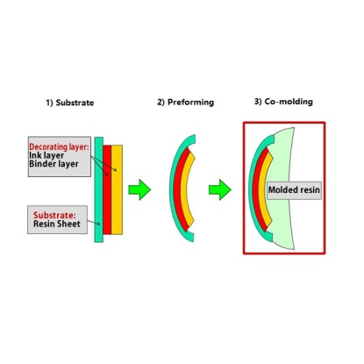 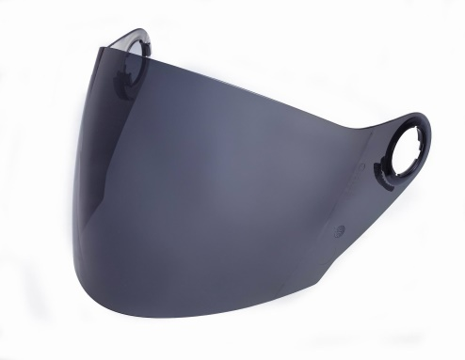

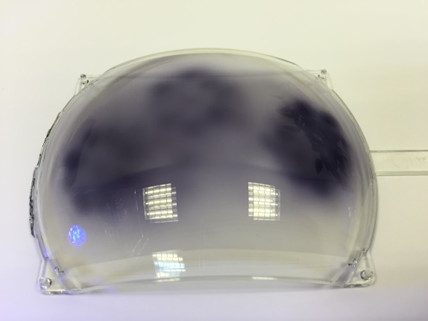 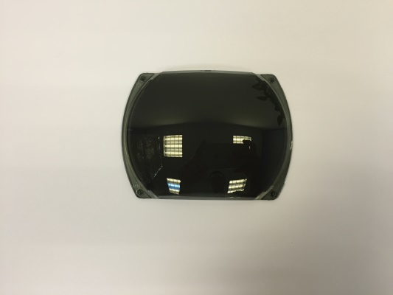

**Photochromic Technology Review of Advantages:**

* Convenience: One piece of photochromic lenses, photochromic visor or photochromic face shield can fulfill varying light conditions.
* UV protection: WeeTect Photochromic Technology (WPT) absorbs 100% UV harmful radiation.
* One stop solution: WeeTect Photochromic Technology (WPT) also combines anti-fog coating, hard coating, abrasion resistant coating, iridium coating or other color tinting together.
* Reduce cost: As a capable photochromic lens manufacturer, WeeTect can support you to reduce cost.

**WeeTect Photochromic Technology (WPT) Technical Data**

