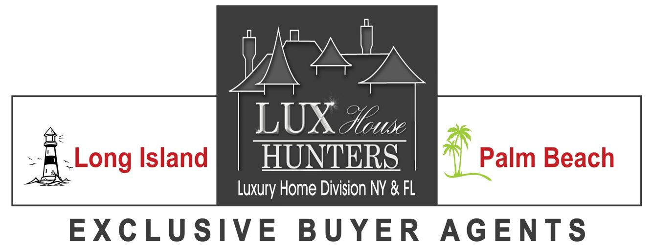

  Direct Line: (516) 721-7394  Lora@LuxHouseHunters.com |  | Designations:  ABRM (Accredited Buyer Rep Manager)  ABR (Accredited Buyers Representative)  CBR (Certified Buyer Representative)  CRB (Council of Real Estate Broker Managers)  CEBA (Certified Exclusive Buyer Agent)  SFR (Short Sale & Foreclosure Resource Certified)  2014- NAR’s REBAC HALL OF FAME  2015 –Top Realtor- Buyer Agency -LI Pulse Magazine  2016 – REBAC Advisory Board  2017 – NAEBA Board of Directors-  Director of Programs & Education  2017 –MRE- Master of Real Estate in Residential Real Estate  Sales, Marketing, & Management- REALTOR® University
Lux House Hunters - Exclusive Buyer Agents, is a real estate brokerage that specializes in working with buyers on their purchases of residential real estate from a $500K to $50M. We represent the Buyer, not the Seller! Lora had the foresight to notice that the real estate market, which is evolving at a rapid pace because of technology, lacked Buyer Agency and proper representation of a Buyer in the purchase of luxury real estate.
Lora’s represents many savvy buyers whom have done their homework and know the benefits of having an Exclusive Buyer Agent! Some of clientele consists of celebrities, sports stars, and high profile individuals buying homes on Long Island and in the Palm Beaches. She also Lora has established herself and has maintained a stellar reputation for the past decade based on integrity and efficiency. Lora has earned the respect of Buyer-Clients and peers alike! Her team of professionals achieves the results you want with no additional commission or fees.
Lora uses her favorite analogy to explain what Exclusive Buyer Agency is to potential clients. She asks, “If you’re getting a divorce, would you have two attorneys representing your future ex and have no one representing you? Then why wouldn't you hire an agent to represent you when you are making one of your biggest purchases in your life?” An Exclusive Buyer Agent is typically compensated the same way as any traditional agent. The fee is dispersed at the closing through the proceeds of the sale. Our firm’s fiduciary duty is only to our Buyer-Client.
Our Firm is a Proud Member of NAEBA (National Association of Exclusive Buyer Agents), NAR (National Association of Realtors), NYSAR (NYS Association of Realtors), FAR (Florida Association of Realtors), LIBOR (L.I. Board of Realtors), (RAPB) Realtor Association of the Palm Beaches, REBAC (Real Estate Buyer Agent Council).
We don’t have listings because we are Exclusive Buyer Agents, but we can take you to every property that you have an interest in and represent your best interest! If you have any questions, please feel free to call or email me.

