
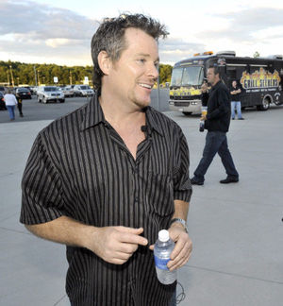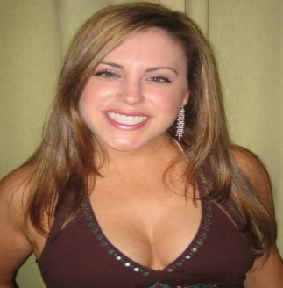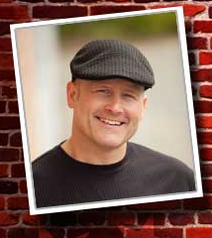
Bill Farrel
Michael Petit
Jessica Casciano
Raffles
Auction

April fool’s day Comedy Night to benefit
Edwina Martin House
Location
I.B.E.W. Hall 256 Freeport St.
Dorchester MA
Come see a crew of comedians
While raising funds for
WOMEN IN RECOVERY Starts at 6:00 PM

Sta

FOOD
MUSIC

Tickets can be Purchased Online: www.emhouse.org
or Call Judy at 508-583-0493
$75 per ticket – tables of 10 can also be purchased

