
UTILITY DNA RECOVERY SWAB (3 in 1)
* Pre-filled with propriety DNA Safeguard Solution * AquaZone Foam tip allows for better DNA release
* Self-contained for easy use in the lab or in the field * Minimal chances of contamination
* Self-drying with no refrigeration needed * Can be used for saliva, blood or Touch DNA
* Invented and patented by a former Police Officer * Patent No. 8,506,898
Touch DNA Instructions-
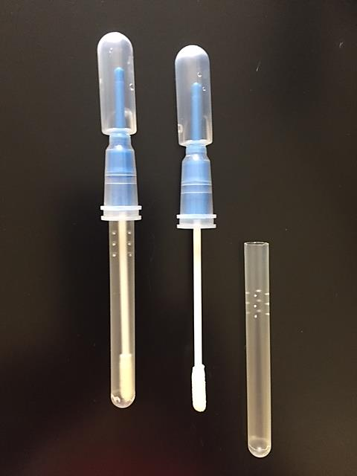
1. Break the snap valve and squeeze the top bubble to disperse the SIM Buffer preservative onto the swab tip.
2. Remove the swab from the transportation sleeve and swab the item to recover the Touch DNA.
3. Replace the swab back into the transportation sleeve for storage. Done!!
CONTACT FOR SAMPLES/PRICING/VALIDATION

Touch DNA Video Instructions:

https://www.youtube.com/watch?v=EdxPEleak6M

Contact us
Phone: 317-213-1251 | Email: vip@perezforensicstrategies.com | Web: http://www.perezforensicstrategies.com

