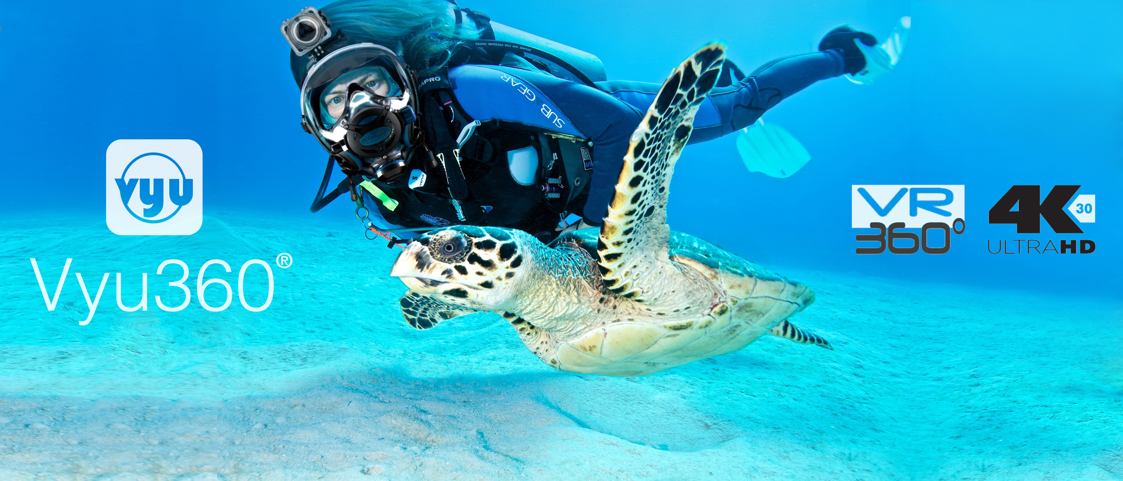Vyu360® Celebrates the Start of the Exciting Age of VR Personal Recording and The Rise of 360 Action Cameras.

The traditional old fashioned action cameras vs the all new 4K VR Action Cameras. It's an interesting question and clash developing that has tech enthusiasts at the edge of their seats with anticipation. Vyu360® 4K VR Action Camera might mark the end of an era and the beginning of something new and its successful Kickstarter campaign an early sign that change might come sooner than expected.

Miami, October 29, 2016 - The impact traditional action cameras have had since their introduction in 2002 can't be overstated. For over 14 years they've captured adventures of all kinds on video, helped people tell their stories in engaging ways and left the world entertained like never before. But tech certainly doesn't stand still and in 2016, insiders are pointing towards a new trend that is about to unravel. It is the beginning of the mainstream acceptance and use of a new technology that has been slowly catching up to and now blowing past the old action camera one.

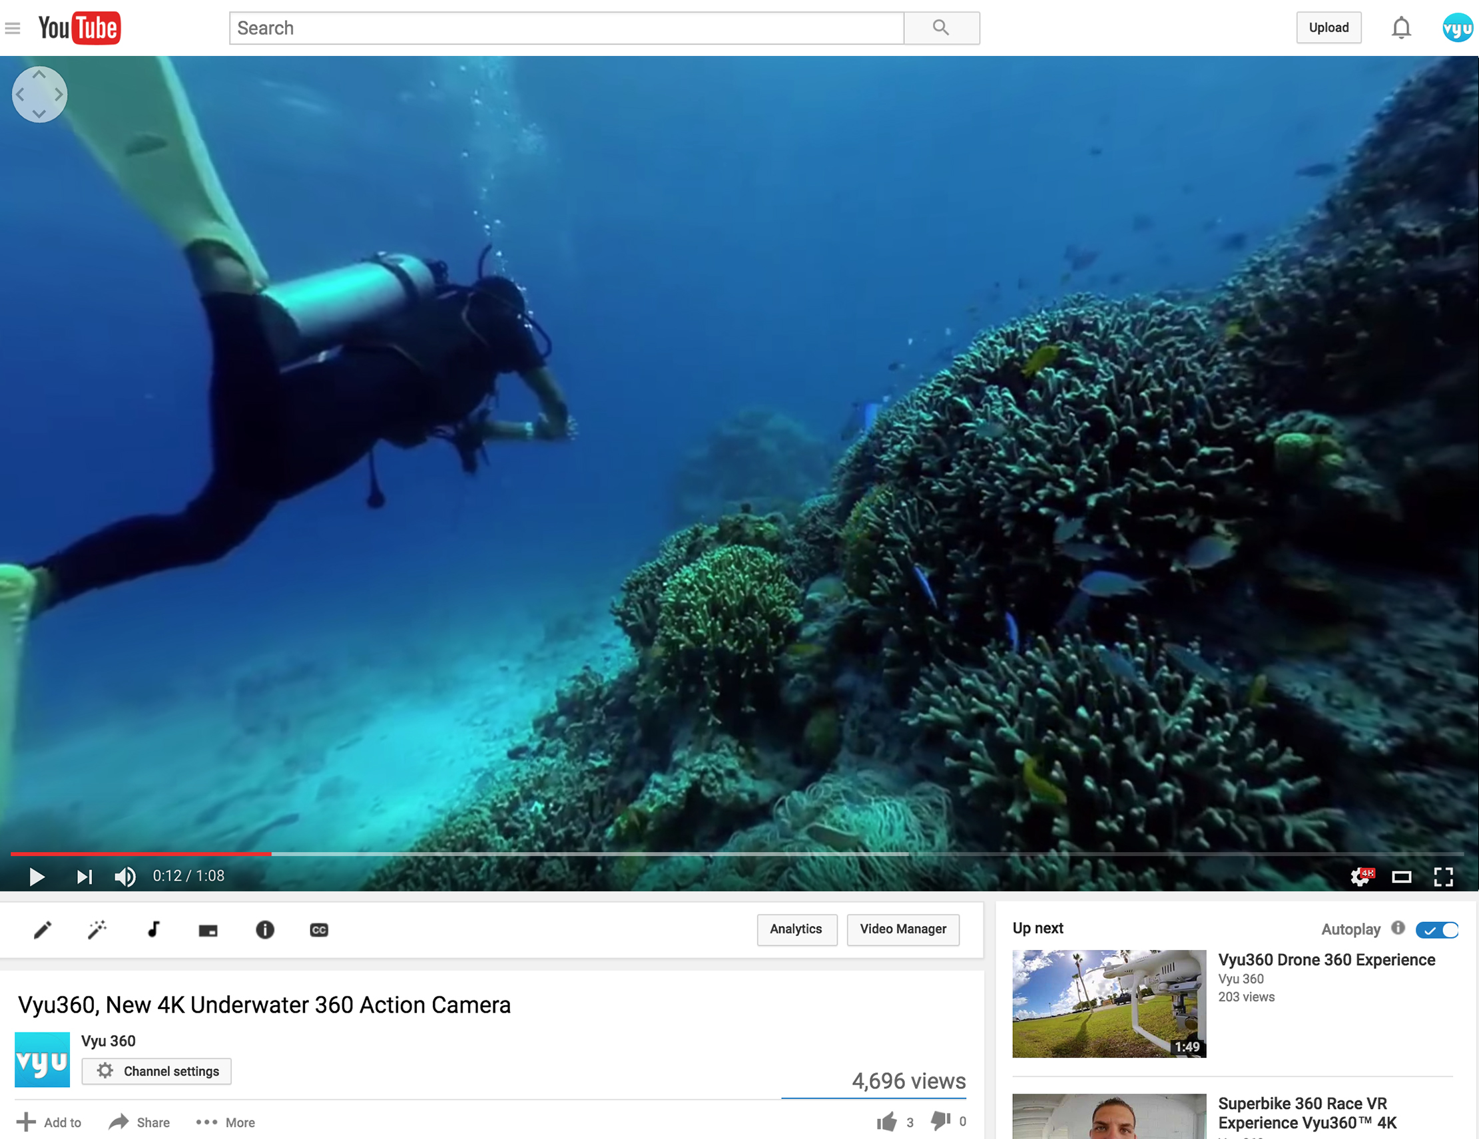
It is important to consider that just few months back on YouTube no 4K 360 videos could be found. Today more 4K 360 videos are present, most of which have been published by professionals. According to Vyu360® the number of VR experiences available will soon increase exponentially and technology like the one they developed might be key to that.

“One of the reasons why VR360 recording is not replacing old video formats just yet is that the public doesn't quite understand what it is being offered to them,” commented Alexis Fernandez, Co-Founder of Vyu360®. “Most people don’t understand the advantages of a 360 VR Camera.

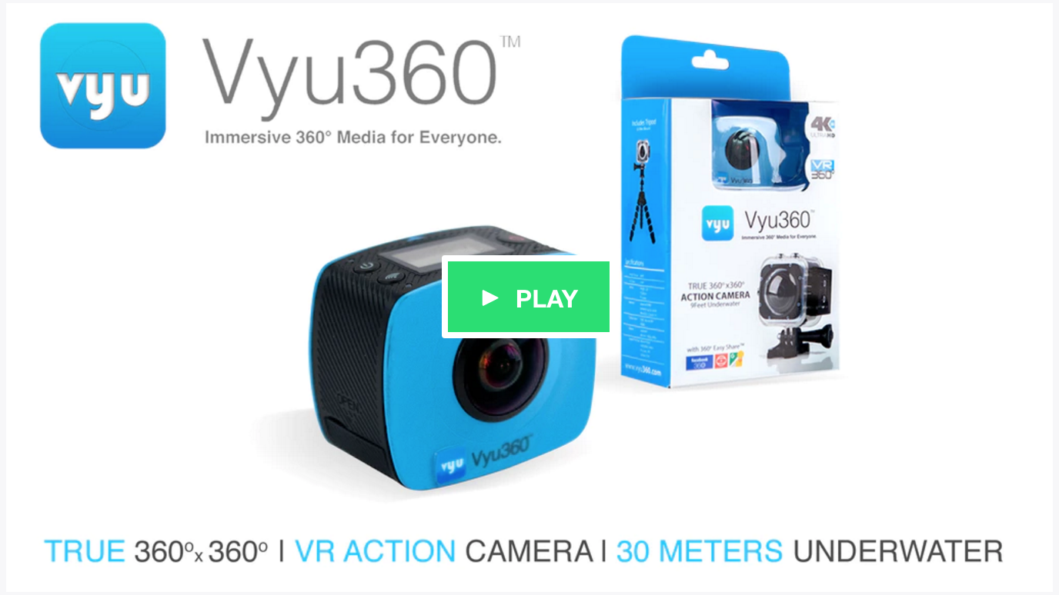
Now that the awareness of what the product offers is rising the demand is going through the ceiling. It's not a shock our crowdfunding campaign on Kickstarter was fully funded in two days... and the excitement just continues to grow around the product.”

Vyu360® developed a WiFi 4K 360 action camera and companion application that enables most smartphones to easily capture and share 360° media, both video, and pictures. The captured media is compiled by the application, making it easy to preview and share across multiple social media platforms.

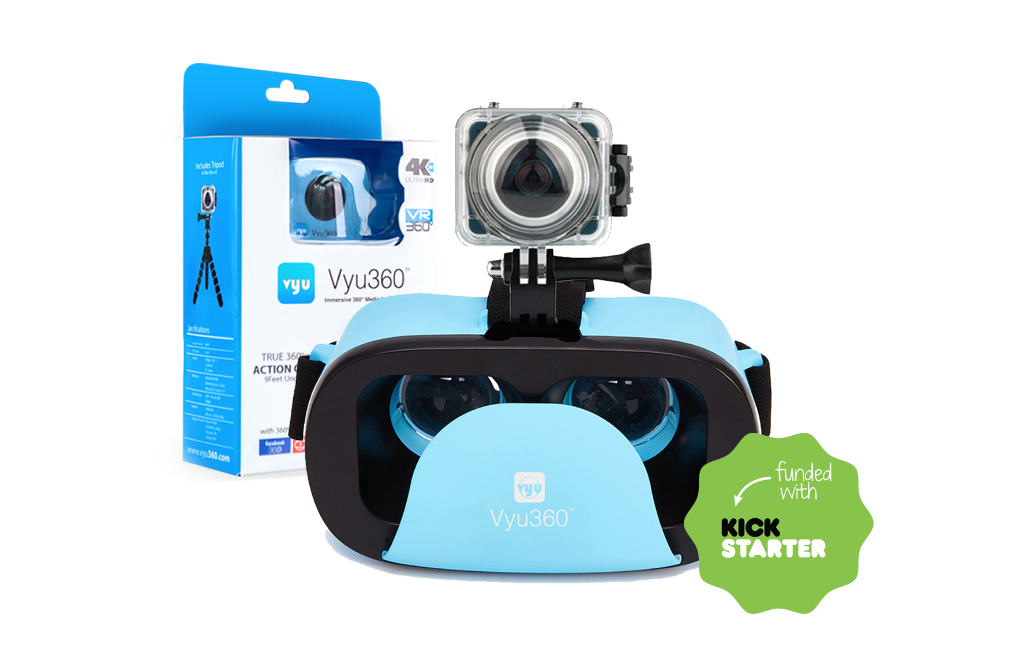
Vyu360® proprietary technology offers a unique and practical solution for average consumers with little to no technical experience to record and share High-Res 360° media directly from their mobile devices.

According to Vyu360® highlights of what makes their technology closer to consumers and unprecedented include:

- the ability to record 360 media in 4K resolution, delivering an absolutely immersive experience that viewers feel like they are re-living rather than watching;

- the ease of use, comparing to traditional footage that requires mixing angles and editing, 360 videos are recorded at a glance and do not need timely postproduction to portrait an experience;

- the ease of sharing,Vyu360® developed an App that facilitates sharing by compiling & uploading media in one shot in most social media network, saving people time and trouble;

- the practical aspect of not requiring recorded media to be downloaded to a PC prior to sharing;

- the IP9K ratings that give the ability to be safely submerged in up to 30 meters of water and withstand any outdoor activity;

- the long lasting and expandable capacity with SD memory cards and long lasting battery for extensive usage.

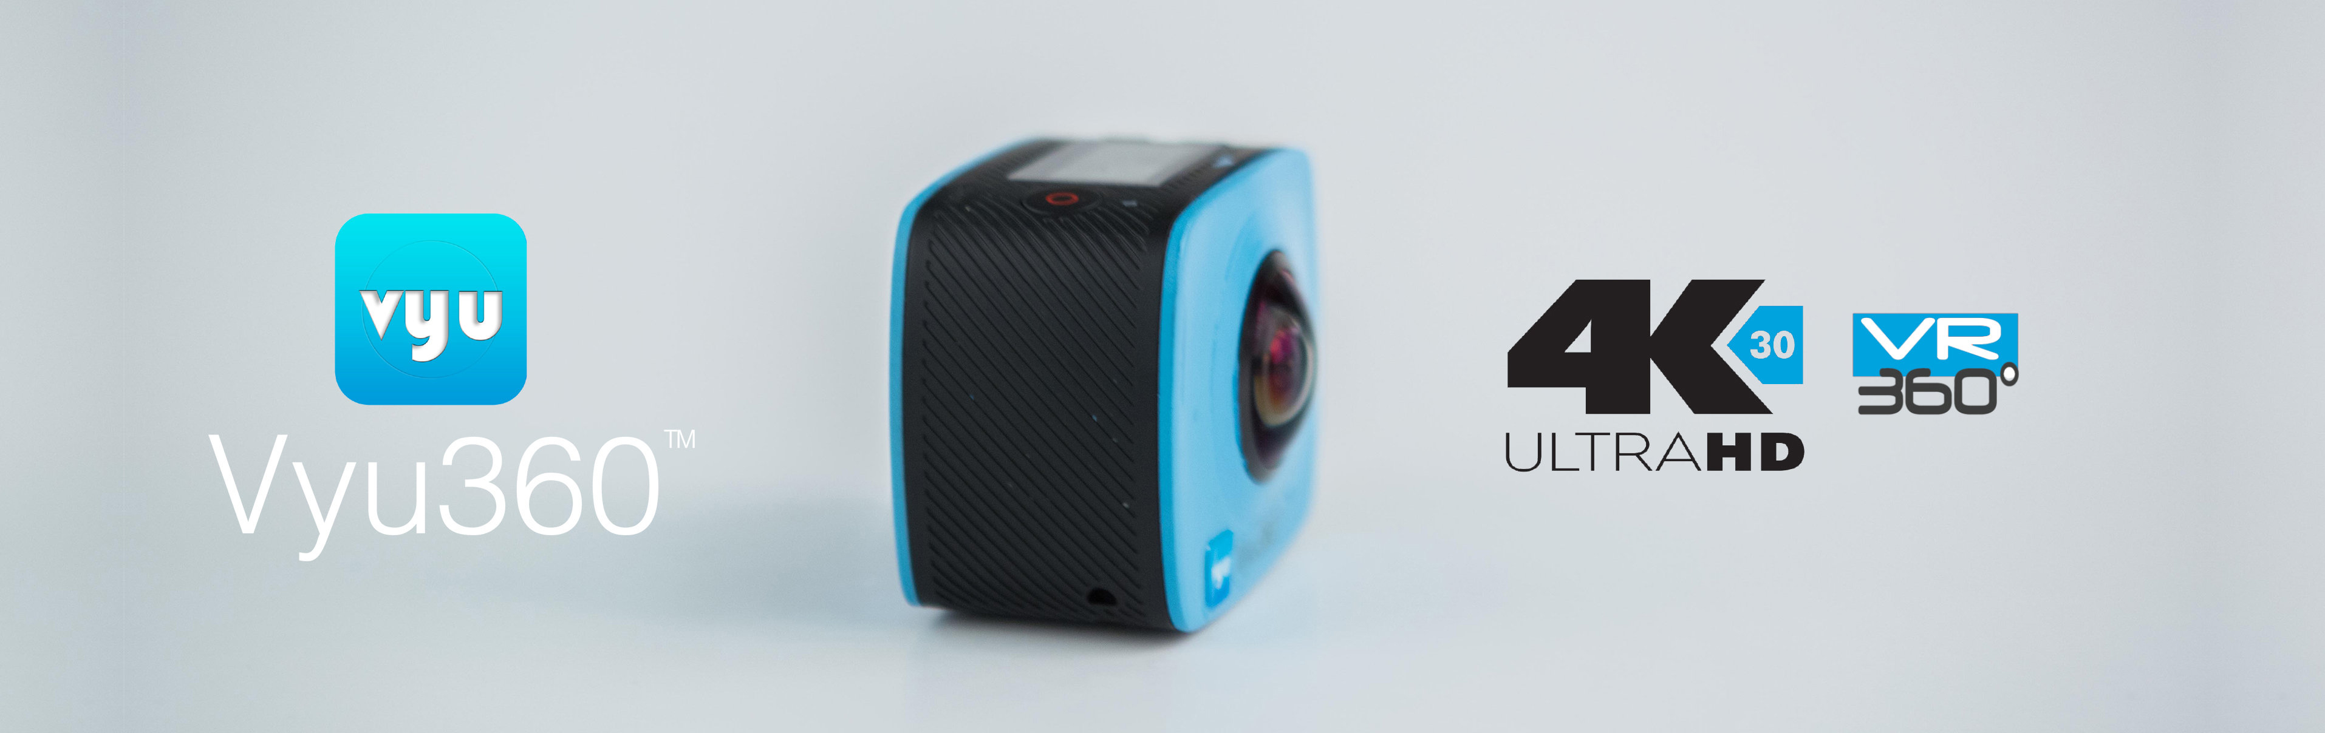

Vyu360® 4K IP9K Action Camera Overview
Vyu360® brings you best in class 4K VR Action Camera that is compact and easy to use. Featuring true immersive 360x360 and live VR 2160p recording capabilities; A long lasting 1800 mA battery with extended 90 minutes recording time; IP9K rated protective case that enables camera to be safely submerged in up to 30 meters of water; Action Mounts to attach camera to helmets, snorkeling mask and more; and finally an attractive price tag on a remarkable piece of tech hardware like no others.

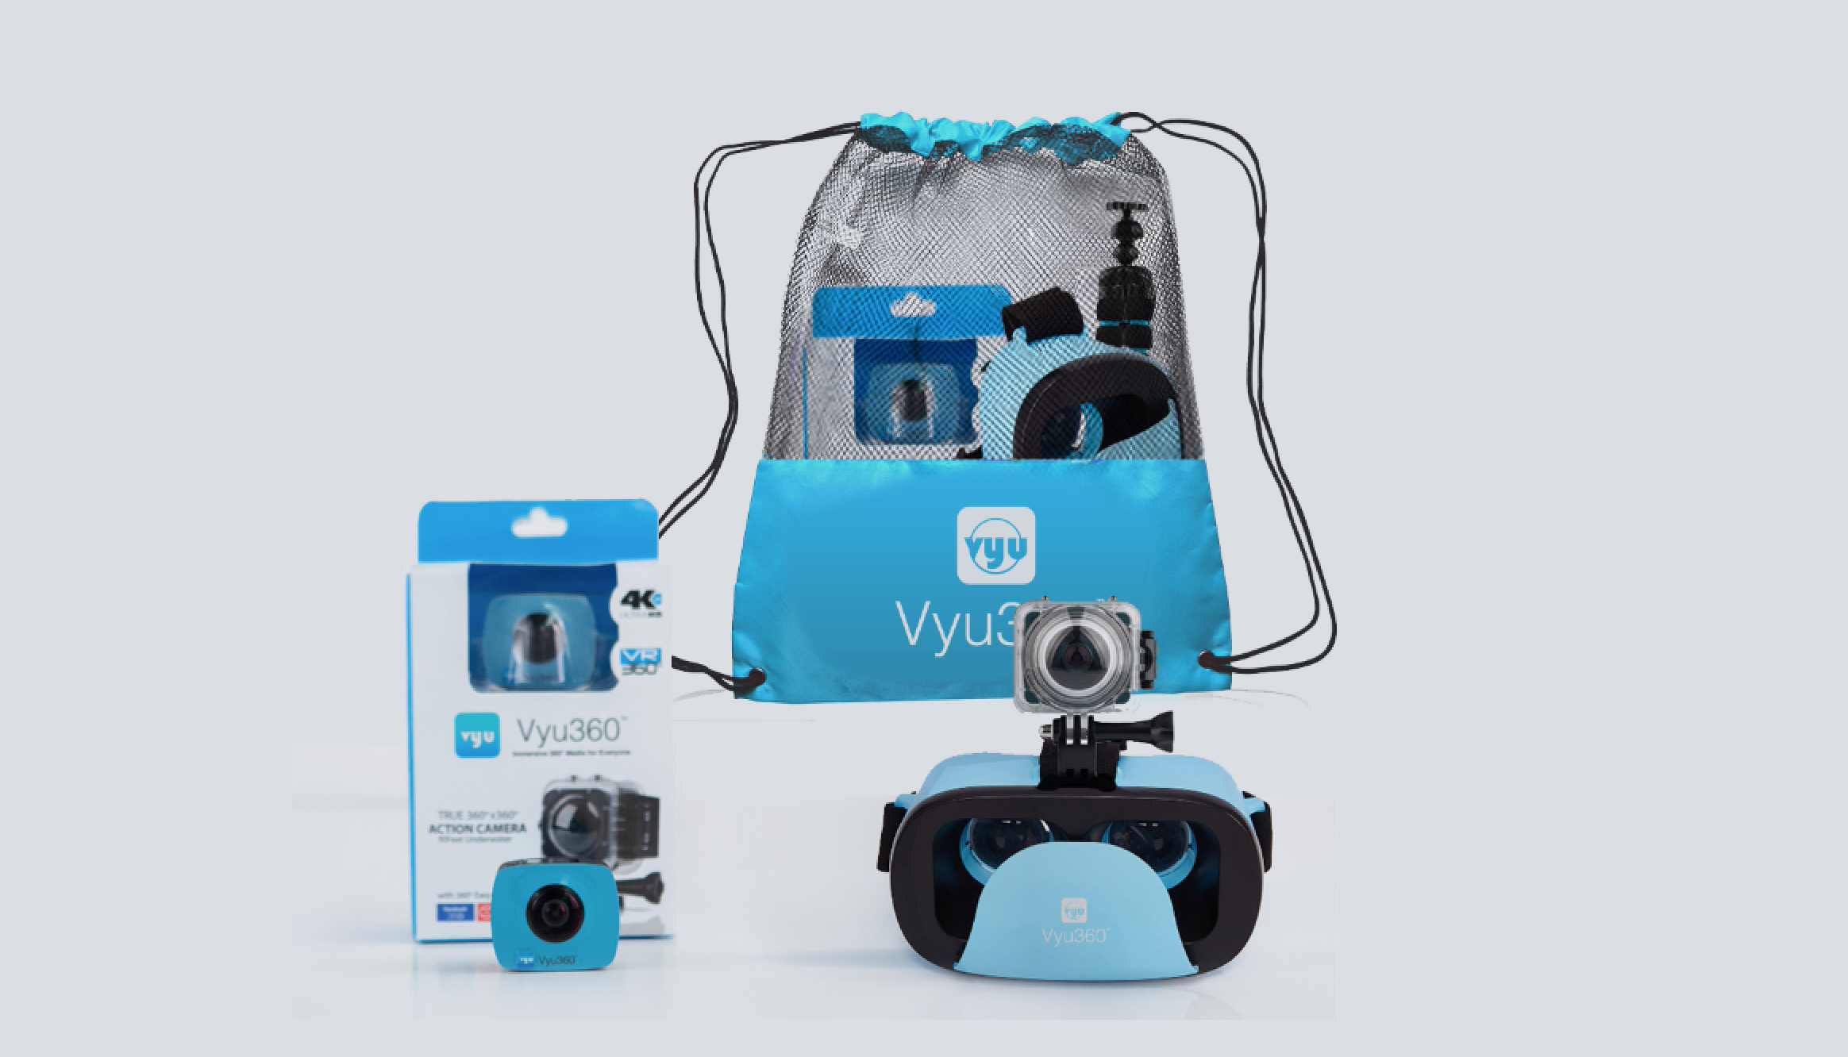
Image Sensors: 8MP (dual lens)
Lenses: 220° each , F2.0mm , f1.1mm
LCD Size: 0.96"
Memory: Internal 8MB, External 32GB included
( Micro SD Class6-10 )
Connection: USB – Micro USB
Battery: 1800mA, 90 min at 960p30fps
Formats: True 360° ( 360°x360°)
Movie H264 2160p 30fps, Pictures JPG 5312x2988
Accessories: IP9K Underwater Case ( 30 meters ),
Tripod, Camera Mount
Optional: Stylish VR Viewfinder

The Vyu360® 4K Action Cam MSRP is $299. The early bird cheapest deal of $179 on Kickstarter is long gone, but there is still one last special priced pledge at $219 that bundles the camera with a VR stylish viewer.

Visit the Kickstarter Campaign if you like to pledge and reserve yours for the holiday. Limited quantity is available with delivery schedule in November.

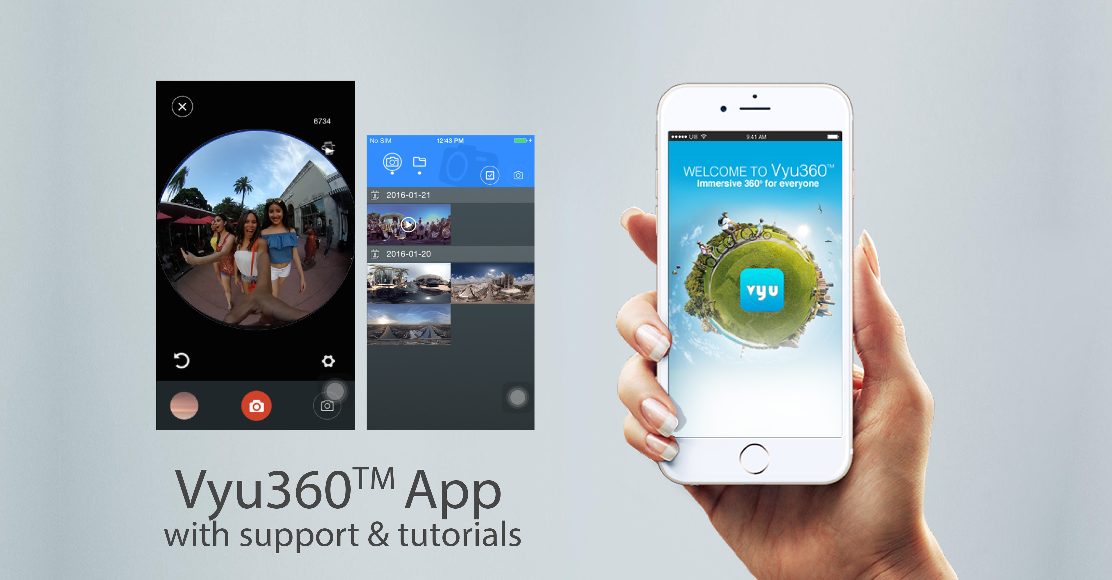

The Vyu360® App Featuring Easy Share
Vyu360® developed an APP that is available for both IOs and Android devices and helps capture and share videos and pictures directly from your smartphone. The APP features a one click compiler that uploads recorded media on a wide variety of social media networks. The App will become available for download last week of November on Google Play and Apple App Store.

The Company
Vyu360® is a South Florida company with the objective to develop hardware and software technologies that aim on making immersive 360 degree & virtual reality media accessible to the masses. Offering solutions across most mobile brands on the market and expanding compatibility with existing capturing devices , Vyu360® aims to position its proprietary software as the universal platform for 360 degree and virtual reality media sharing.

Stay tuned for more information visit:
Kickstarter Page: http://kck.st/2ebvfnj
Website: http://www.vyu360.com
@Vyu360.com
Public Relations:
vyu360@gmail.com

Investor Relations:
Maurizio Festa
mauri@vyu360.com

