Inclusive Technology wins second successive Queen’s Award

EMBARGOED: Strictly not for publication before 00:01 Hours on 21 April 2017

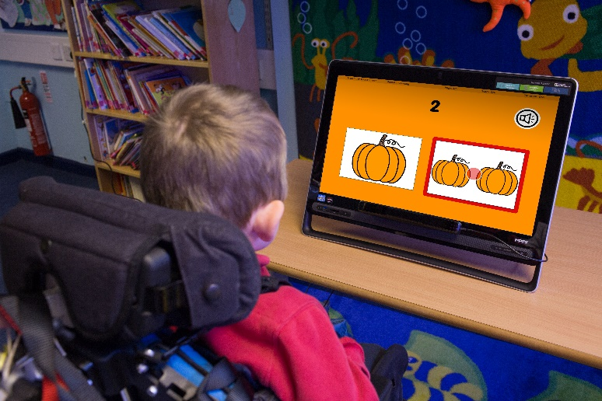

Bailey from Pendle View School uses eye gaze technology to access ChooseIt! Maker 3

Inclusive Technology has won Britain’s top business award for a second consecutive year. The company has received a 2017 Queens’ Award for Enterprise Innovation having won a Queen’s Award for International Trade in 2016. Inclusive Technology, which is based in Oldham, Lancashire, develops and sells assistive technology for learners with special educational needs.

The 2017 ‘Queen’s Award for Enterprise - Innovation’ has been awarded for ChooseIt! Maker 3 (CM3).

CM3 is a popular online classroom resource for learners with special or additional needs. It allows teachers to create activities, personalised for an individual child or teaching group.

To create a personalised activity teachers can add images, take photos, record sounds, draw or paint. In addition there is a built-in searchable media library with 30,000 pictures and symbols allowing the creation of national or core standard curriculum activities in minutes. Every CM3 activity automatically records each learner’s progression and achievements. Results can be saved and shared with the learner’s parents.

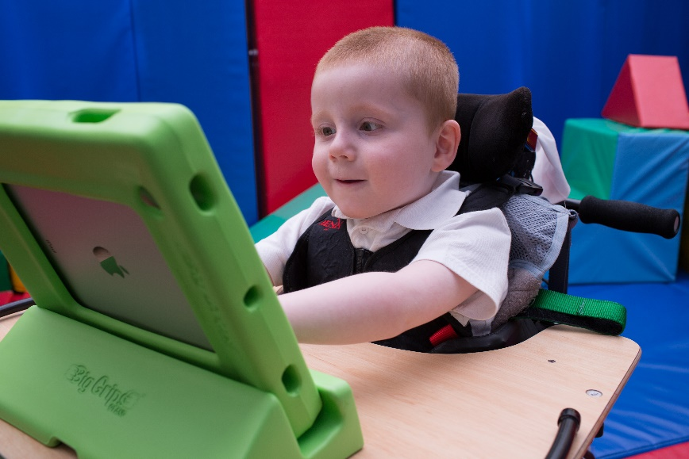
Kenzie enjoys an iPad App created for him which he can use offline, anywhere.

Once created the activity can be used on the classroom computer or, crucially, published as an App to be used anywhere offline — at home or in the family car for instance. To date 97,000 activities have been created. Each can be shared freely with classmates or with a twinned school here or overseas.

Martin Littler, a founder and the executive chairman of Inclusive Technology said:

“I’m so delighted to receive a second successive Queen’s Award. It’s a great reward for our animators, graphic artists and coders as well as our specialist education and speech therapy staff — indeed the whole team. ChooseIt! Maker 3 enables kids to make choices — that’s fundamental to independence, communication, learning — everything.”

ChooseIt! Maker 3 won the top software awards in Britain and in the United States in its first year.

2014 British BETT Award - 'ICT Special Educational Needs Solutions'
2014 American SIIA CODiE Award - 'Best Solution for Special Needs Students'

Notes for editors:

The Queen's Awards for Enterprise is an awards programme for British businesses who excel at international trade, innovation or sustainable development. They are the highest official UK awards for British businesses. The award winners are announced on the Queen’s Birthday, 21 April, and are strictly embargoed until then.

The Queen will hold a Reception for the winners at Buckingham Palace on Tuesday 11 July 2017. Subsequently, the Queen’s representative (a Lord Lieutenant) will present a ‘Grant of Appointment’ and a commemorative crystal bowl.

Inclusive Technology was founded by three teachers as a division of Ocean Software in 1996. The three staged a management buy-out in 1998 and set up Inclusive Technology Ltd. Inclusive specialises in the supply of communication and learning technology to special education and health customers and has a world lead in the production of accessible software for learners with complex learning difficulties and disabilities (CLDD).

Accessible Software is designed to include learners with a disability who may only be able to make a single voluntary movement. It enables access through adapted keyboards or mice, joysticks, rollerballs, touch screen or touch panel technology, one or two switches and eye gaze technology.
Eye gaze technology is often the most efficient way for those with very limited voluntary movement to access a computer and to communicate. The camera technology follows eye movement and effectively acts as a mouse.

In 2016 Inclusive Technology won ‘The Queen’s Award for Enterprise - International Trade’ for its cloud-based educational resource HelpKidzLearn. This is a collection of over 100 accessible activities for children with special needs. The Award recognised the international success of this online subscription service which is used in 153 countries with over half of current subscribers in the United States.

Press Contact: Mick Archer (mickarcher@me.com) +44 (0)7565 961444.

Martin Littler (martin@inclusive.co.uk) +44 (0)7970 262674 is available for interview.

To read more or try ChooseIt! Maker 3 www.helpkidzlearn.com/cm3-trial.

High-resolution versions of the images above are available on request.

