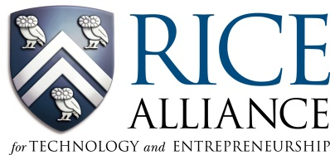
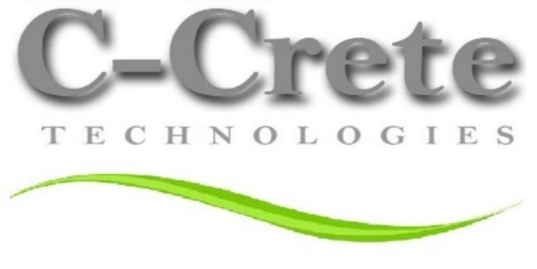

FOR IMMEDIATE RELEASE
info@ccretetech.com

C-Crete Technologies LLC Named Most Promising Energy & Clean Technology Company at Rice Alliance Energy & Clean Technology Venture Forum

Houston – (Oct 4. , 2016) - The Rice Alliance for Technology and Entrepreneurship (Rice Alliance) announced the 10 Most Promising Energy & Clean Technology Venture Companies at the 14th Annual Energy & Clean Technology Venture Forum in Houston. Energy & Clean Technology companies showcased their new offerings at the largest venture capital conference in the Southwest with 500 attendees, including investors, venture capitalists, industry representatives, business leaders, service providers, and entrepreneurs.

The one-day event culminated in an announcement of the 10 Most Promising Energy & Clean Technology Companies Award companies chosen from 55 presenters and judged by the Rice Alliance Energy & Clean Technology industry experts and interest generated from participating investors.

Six of the ten most promising companies are based in the Houston area: C-Crete Technologies LLC, AIDAP, Ashmin, Big Delta Systems, Inc., Encline Artificial Lift Technologies LLC and IReamer LLC. The other five companies represented diverse regions, including: Motive Drilling Technologies from Dallas, HyperScience, Inc. from Spokane, WA and two international companies: Impact Technology Systems from Oslo, Norway and INGU Solutions from Ontario, Canada. The announcement of the top companies was made at the end of the program.

“Every year the quality of companies improves,” said Rice Alliance managing director Brad Burke, who presided over the announcement of the winners of the Energy & Clean Technology Venture awards at the event. “Over the past 14 years, more than 1,800 companies have presented at Rice Alliance Technology Venture Forums. These companies have raised more than $3.1 billion in funding. This speaks to the quality of the companies and to the robust entrepreneurial ecosystem of investors that has been developed to support these companies. Despite the challenging economic environment over the past several years, good companies have been able to attract investors.”

C-Crete Technologies LLC was named one of the Energy and Clean Technology Venture Companies at the forum. C-Crete is developing advanced materials that are scalable, efficient and low-cost to address the grand challenges related to energy and CO₂ emissions.

“When it comes to extracting energy from oil and gas resources, well cementing is a key process whose failure can entail billions of dollars in remedy and huge environmental impacts. We are developing a programmable self-healing material that can not only restore the mechanical properties of well cement but also it mitigates the gas and liquid escapes. Our patented technology can be used in both primary and remedial well cementing to increase efficiency, eliminate the halt in production and prevent disasters such as the 2010 oil spill in Gulf of Mexico or the 2015 Aliso Canyon incident in California” Said Dr. Rouzbeh Shahsavari, the Founder and Chief Scientist at C-Crete.
“We are also developing a compact, low cast, and durable membrane technology for applications such as CO₂ capturing from power plants, gas sweetening, and recycling CO₂ in enhanced oil and gas recovery. These technologies can have enormous impacts on curbing energy usage and CO₂ emissions worldwide” said Shahsavari.

The Forum was supported by Chevron, Shell, Wells Fargo, Aramco Energy Ventures, BP, Baer Hughes, ConocoPhillips, Energy Ventures, FMC Technologies, GE, Statoil, Technip, Total, Andrews Kurth, Norton Rose Fulbright, Altira, Lime Rock Partners, OTM, Leyendecker Executive Search, Jeb & Co. Winstead with supporting organizations Greater Houston Partnership, Canadian Consulate and CleanTech Open, Energy Valley, Inc. Houston Angel Network.

###

About C-Crete Technologies LLC: C-Crete is a multiple award-winning company based in Houston that is focused on manufacture and commercialization of advanced materials and composites. The primary mission of C-Crete is to design scalable materials for a low energy, low carbon world by leveraging advanced synthesis, characterization and testing. The company has won several prestigious entrepreneurial awards including the grand prize of MIT’s $100K Business Plan Competition, and has been featured in several mainstream media including the New York Times, Forbes, Reuters, etc.

