Press Release
For Immediate Release

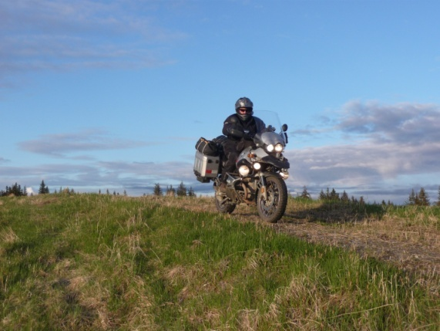
Anchorage, Alaska—1 June 2013-- Travessilla Expedition (TravEx) announced its partnership with Klim, the premier adventure clothing company. Klim has agreed to furnish the motorcycle riding gear for TravEx’s 86 country motorcycle expedition. The 3+ year expedition is dedicated to saving the lives of children suffering from dysentery.

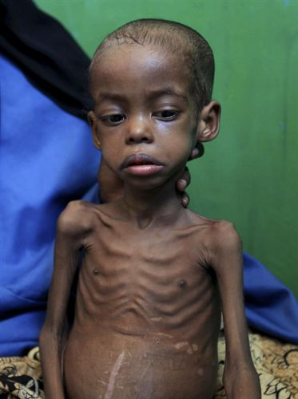
“In all my years of doing wild and often very dangerous things, I am more excited about this expedition than anything I have ever done.” Said Dr. Randy McKinney, Expedition Leader. “When you see little kids in a third world country dying from not only a preventable but also a curable disease like dysentery, it just breaks your heart……no….it is much, much worse than that. It absolutely crushes your heart, it did mine. After that, I knew that my wife and I had to do everything we could to save as many of these children’s lives as possible. And TravEx was born out of that heart wrenching experience.”

TravEx is truly an epic journey, covering 86 countries over the course of three to four years. What makes this expedition fall under the oft overused adjective “epic”? Well, this…..Very much un-like nearly all real long motorcycle expeditions, TravEx will not be supported by chase vehicles. With the exception of some re-supply items that will be pre-positioned at several points on their route (new motorcycle tires and spare parts, new clothes, spare (read clean) sleeping bags, additional medical supplies, and etc) they will be completely on their own. Just two people on two motorcycles, using their wits and ingenuity to overcome all the obstacles and challenges. Living in a small tent, sleeping on the ground with a thin pad and a sleeping bag, eating what they can purchase at local markets and cooking it on a single burner camp stove. They will swat mosquitoes, sweat, shiver, get motorcycles stuck and un-stuck, ford streams, bathe in cold rivers, travel in the pouring rain and the hot sun, be very cold, wet, and tired and then very hot, thirsty, and exhausted. They will see the unimaginable suffering of children in refugee camps with moments when they wonder “What on earth are we doing here? We could be warm, dry, safe and well rested in the home that we gave up for this.” At other times, they will be completely elated from being able to save the life of a child with dysentery.
And that is what makes this expedition epic, in the truest sense of the word!
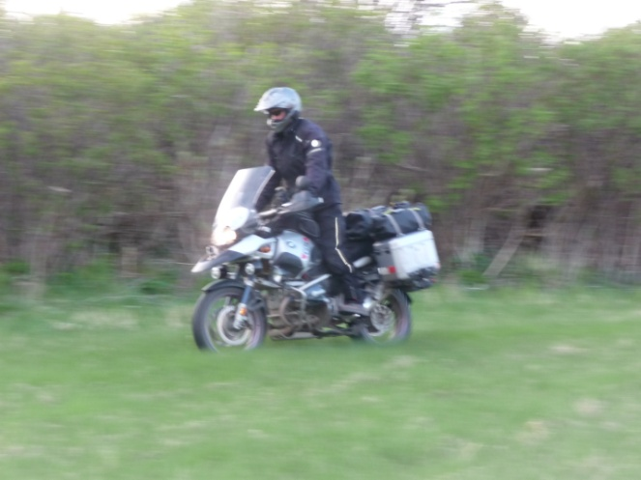
“I am absolutely thrilled to be going on this expedition!” Said Dr. McKinney’s wife Lana. “God has a calling on our lives, we are called to go and make a positive difference. We are so blessed as Americans and I am happy to go be a light into the world. It will often times be a very grueling trip but extremely rewarding at the same time.”
Are you interested in taking some part in this expedition or becoming a supporter? Contact them through their web site. They would love to hear from you. www.travessillaexpedition.org.

