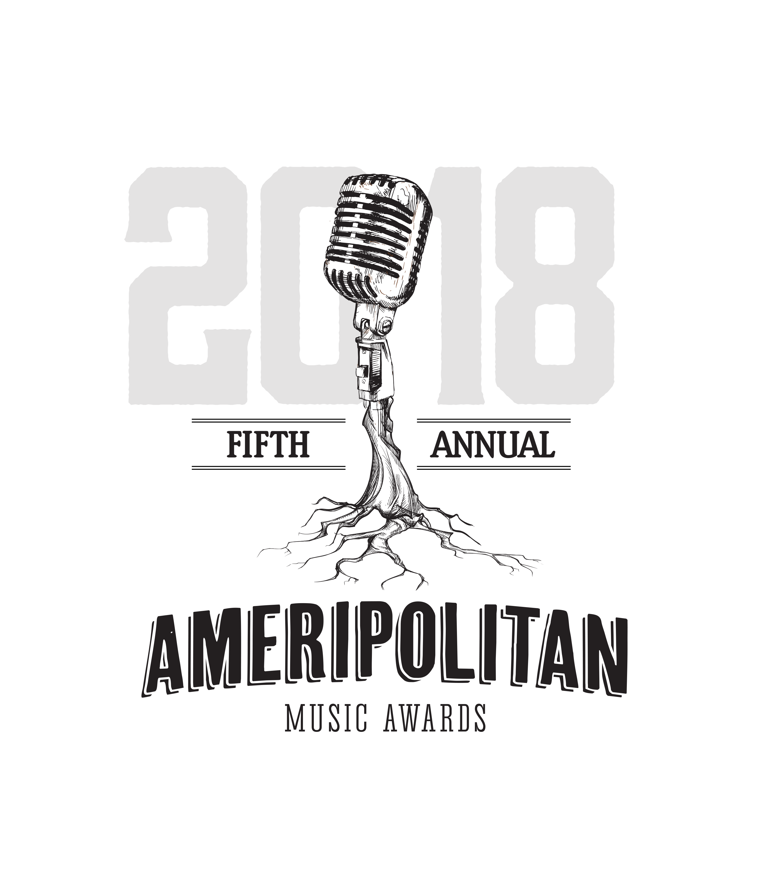
FOR IMMEDIATE RELEASE
August 15, 2017

MEDIA CONTACTS:
Nicole Shiro | 512.740.6665 | nicole.shiro@motleycrewmedia.com
Amy Simpson Layton | 512.695.0799 | amy.layton@motleycrewmedia.com
Photos available upon request

5th ANNUAL AMERIPOLITAN MUSIC AWARDS MOVES TO MEMPHIS
THE GUEST HOUSE AT GRACELAND | TUESDAY, FEBRUARY 13, 2018
Nominations for Ameripolitan music’s biggest night begin Friday, September 1, 2017

WHAT: 5th Annual Ameripolitan Music Awards
WHEN: Tuesday, February 13, 2018
Doors open at 7 p.m. / Awards Ceremony at 8 p.m.

WHERE: The Guest House at Graceland / 3600 Elvis Presley Blvd / Memphis, TN 38116
TICKETS: On-sale Tuesday, August 15 and will be available at gofundme.com
(Austin, TX) – The 5th Annual Ameripolitan Music Awards moves to Memphis, TN and the home of Elvis, to The Guest House at Graceland on Tuesday, February 13, 2018, at 8 p.m. Ameripolitan Music Showcases will kick off the celebrations beginning, Saturday, Febuary 10, 2018. Nominations will open to the general public on Friday, September 1, 2017.
“The 2018 awards show will mark a new milestone for the genre," says renowned musician Dale Watson. "Austin has been great to us, but when we first started the awards, the dream was to bring the Ameripolitan Music Awards to different host cities. And for the fifth year, moving to Memphis, the epicenter of roots music, seemed like a natural progression. Every year we strive to take the Ameripolitan Music Awards to a new level, and moving to Graceland seemed like the perfect fit.”

Dale Watson coined the term “Ameripolitan” to describe his own brand of original roots music – when moved by remarks made by Ray Price in defense of his style of traditional music. Seizing the moment, Watson embarked on the ambitious goal of organizing an Ameripolitan Music Awards show.
Jerry Phillips’ welcomed the Ameripolitan Music Awards with the message, "As my father Sam Phillips said many times..."For God's sake, let's don't become conformists"...Ameripolitan is a tie to the past and a door to the future...Welcome to Memphis."
Ameripolitan Music Awards Schedule of Events:

- Saturday, February 10:
- Outlaw and Honky Tonk live music showcases at The Guest House at Graceland Theater 6pm to 9pm
- Sunday, February 11:
- Western Swing and Rockabilly live music showcases at The Guest House at Graceland Theater 6pm to 9pm
- Monday, February 12:
- Ameripolitan Fashion Show at The Guest House at Graceland Theater 3pm to 5pm
- Exclusive VIP party at Sam Phillips Recording Service hosted by Jerry Phillips
- Tuesday, February 13:
- The 5th Annual Ameripolitan Music Awards show in the Main Ballroom at The Guest House at
Graceland 8pm to 11:30pm
- After Party, 12am to 2am, Venue to be announced at a later date

A small following of “true believers” helped make the first Awards a reality. The event featured award winners selected by fans, starring an abundance of independent roots artists. Bonded together by this momentous occasion, both fans and performers of Honky Tonk, Rockabilly, Western Swing and Outlaw music inaugurated a new genre of music that night.
Exceeding all expectations, in just five years Ameripolitan Music has been warmly embraced by fans worldwide and has become home for the best talent roots music has to offer.
Nominations are open for all categories beginning Friday, September 1 and will conclude on Friday, September 22. Please send an email to info@ameripolitan.com to submit your nomination. ONE NOMINATION PER PERSON. For official nomination and voting rules, information on categories, updates and breaking news, please visit Ameripolitan.com as well as the Ameripolitan Awards social networks on TWITTER and FACEBOOK.
About Ameripolitan Music Awards: Under the leadership of Texas Honky Tonk legend, Dale Watson, the Ameripolitan Music Awards was created to acknowledge the exceptional creativity and dedication of roots artists whose work does not readily conform to the tastes of today's "Country", or other music genres and organizations. Ameripolitan Award Productions, a 501c3 non profit organization which produces the Annual Ameripolitan Music Awards show, was founded to benefit and acknowledge these artists. It also provides fans with a means of finding these artists and their music.
Ameripolitan – This thought-provoking word is intended to be an invitation to discuss the future of the music that is important to so many. It is music that has heart and guts. The goal of Ameripolitan Music is to help reestablish this music’s own unique identity, elevate its significance and help reinvigorate it creatively. Also, because of our place in history, we have the privilege and responsibility to pass a great musical tradition on to future generations who will otherwise have no direct connection to this music.
The Ameripolitan Music Awards acknowledges those Ameripolitan artists whose music honors tradition while demonstrating exceptional originality, creativity, and musicianship. Through their work, Ameripolitan music is now being defined. The Awards also acknowledge Ameripolitan DJs and venues that promote these artists and their music along with honoring a living legend who has kept the tradition alive through their music and perseverance.
Though it has been shaped by many musical and technological influences, Ameripolitan roots can always be traced directly back to the tradition of honky tonk piano players and small string bands creating music to be played for a dancing and drinking crowd. As a result, this music tends to be participatory by nature with the band and the audience experiencing this music together, both physically and emotionally.
TO REQUEST INTERVIEWS CONTACT NICOLE SHIRO @ nicole.shiro@motleycrewmedia.com

# # #

